1. Employee Code display as Empty in Leave form pop up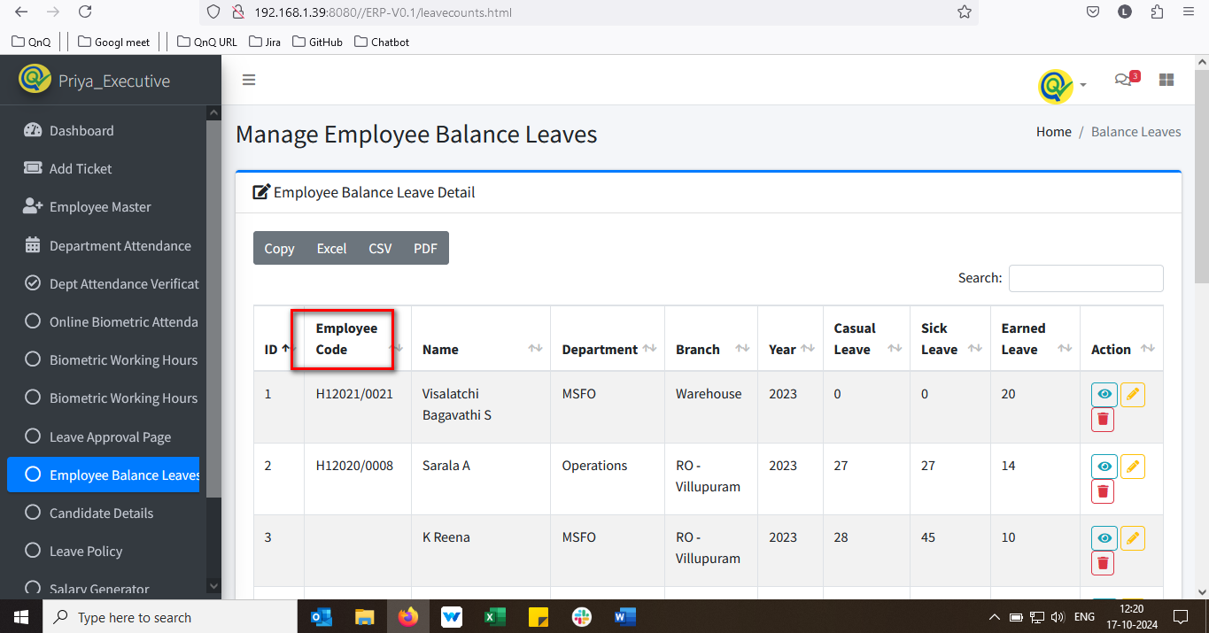//
2. The "Add New" button is positioned at the bottom of the list grid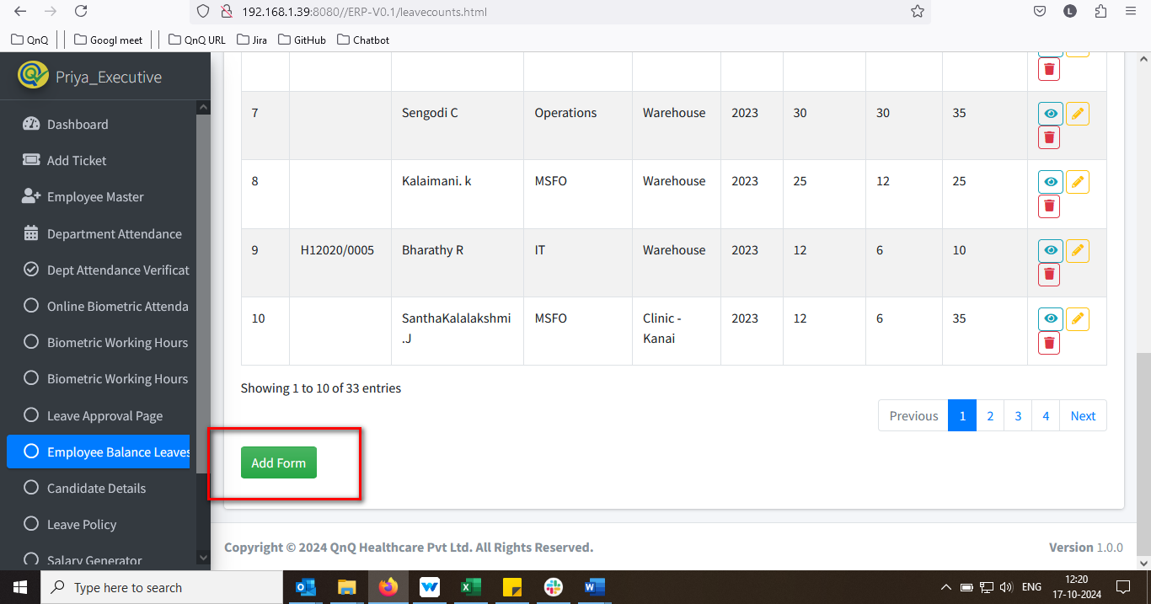//
3. Add new button name not display as Apply Leave//
4. Mismatch Page Tile display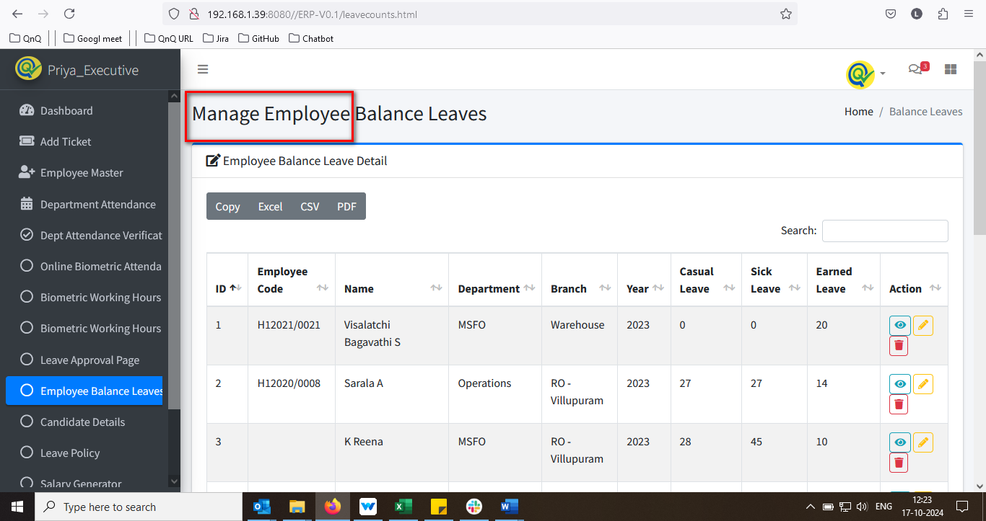//
5. List grid column not display properly while zoom out the page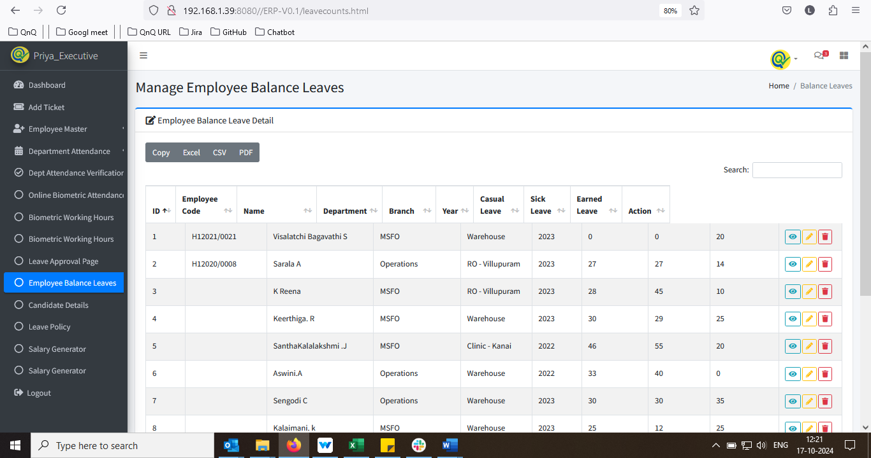//
6. Year based filter not display in the list grid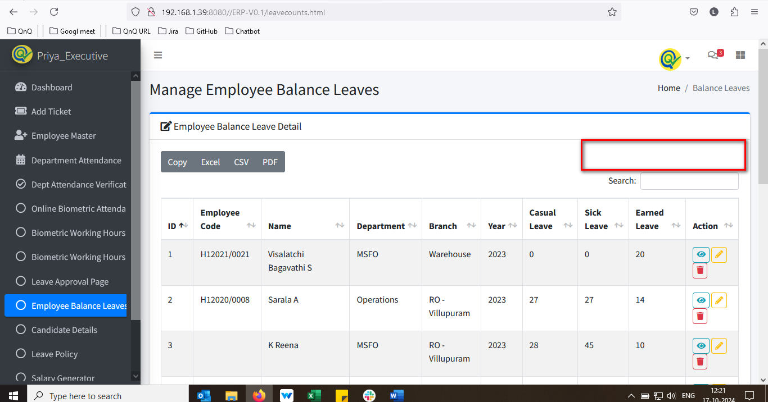//
7. The initial letter appears as a lowercase letter for Edit/View/Delete icon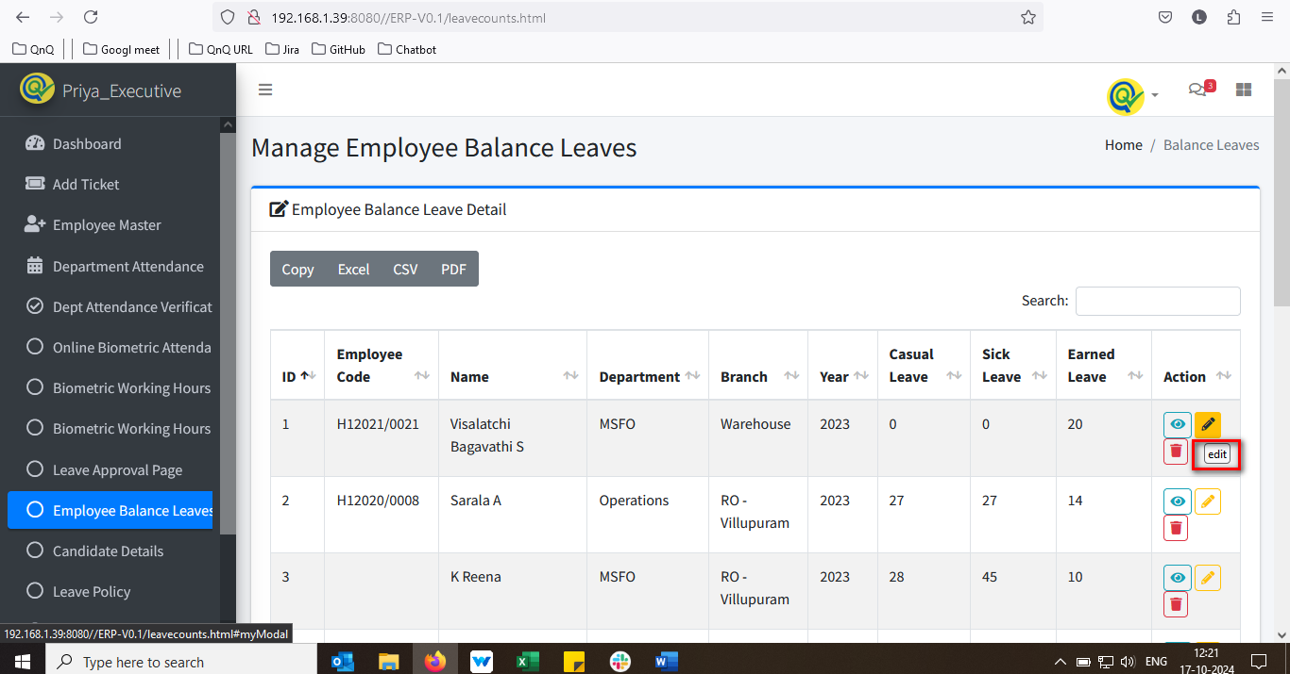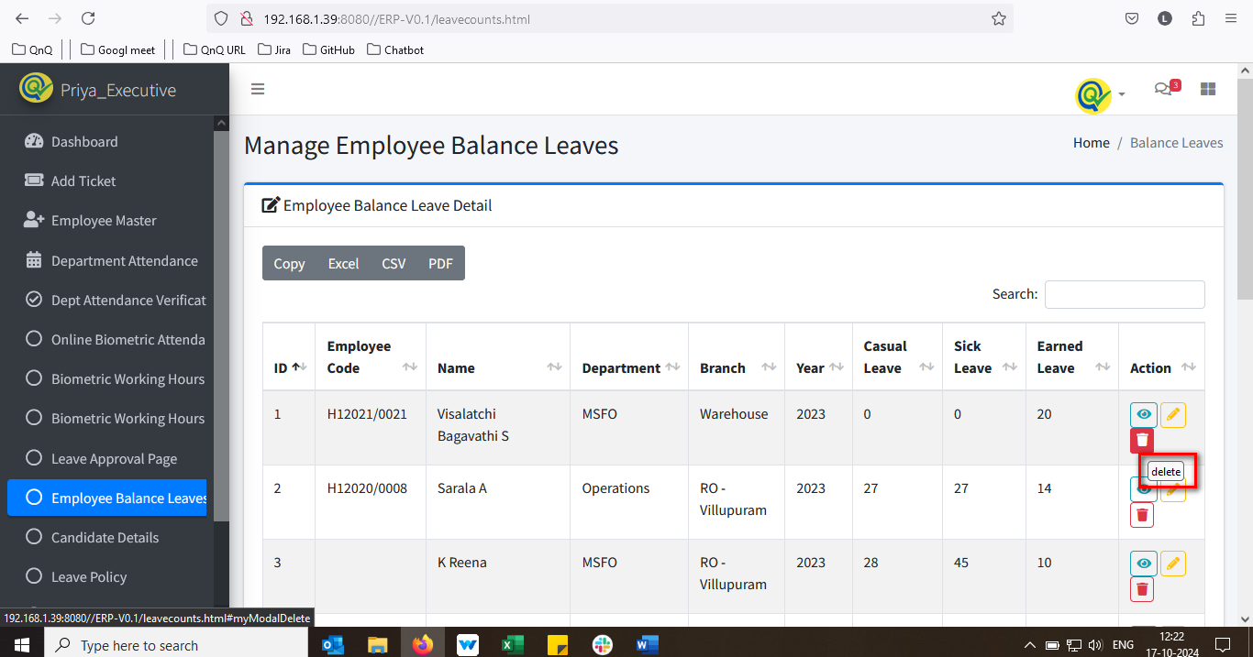//
8. Employee name column name display mismatch value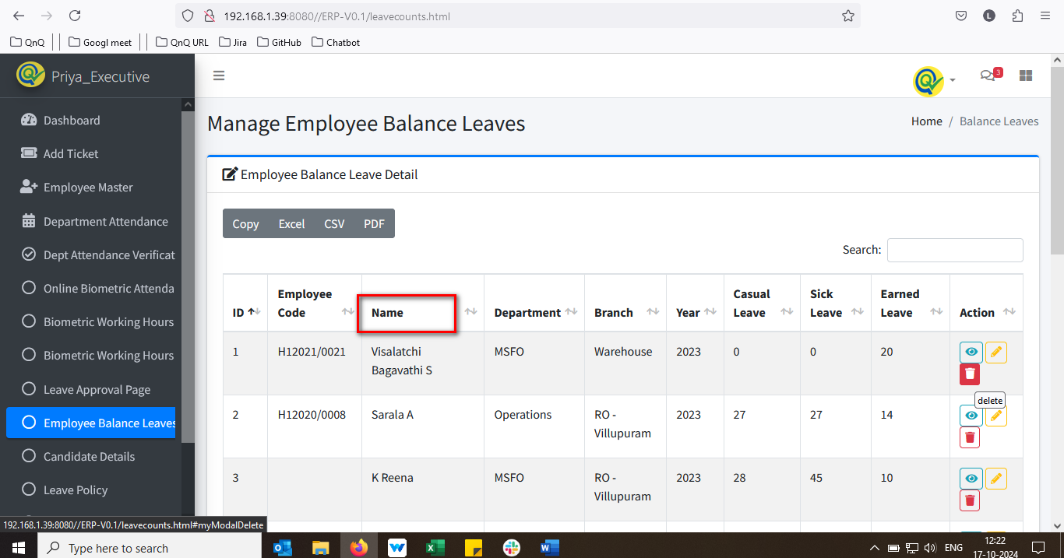//
9. Mismatch column name display in list grid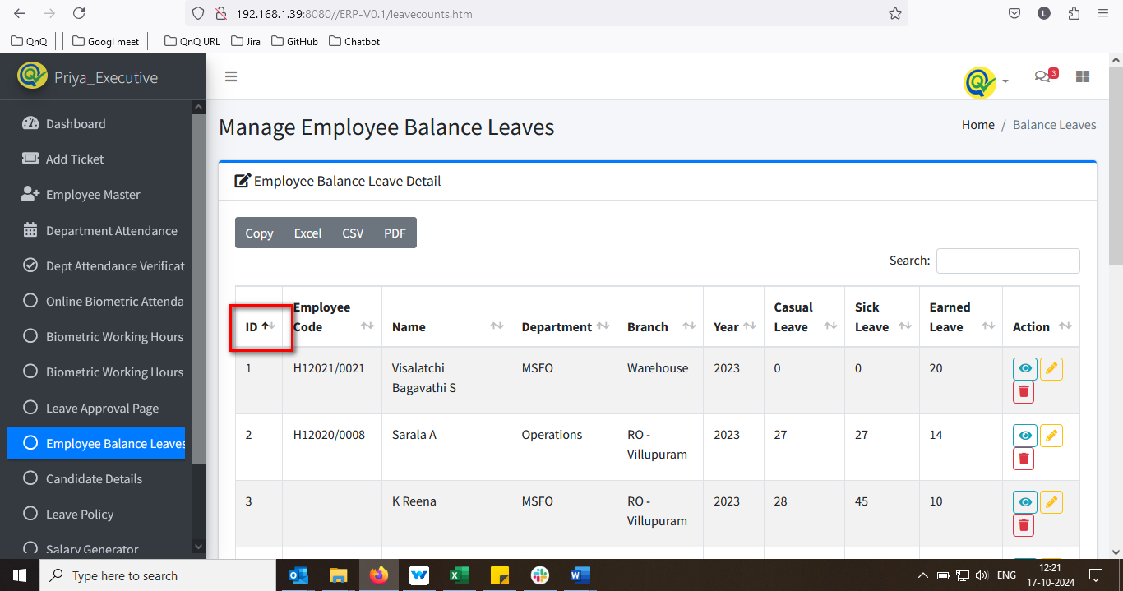//
10. Tool tip not display for Close icon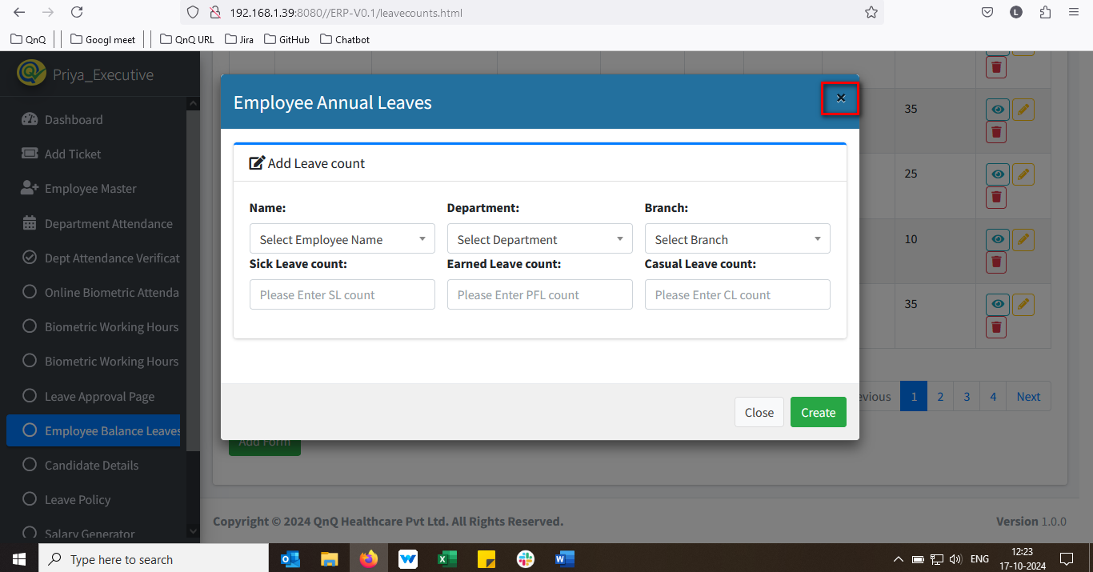//
11. Leave count field allow more than 100 characters 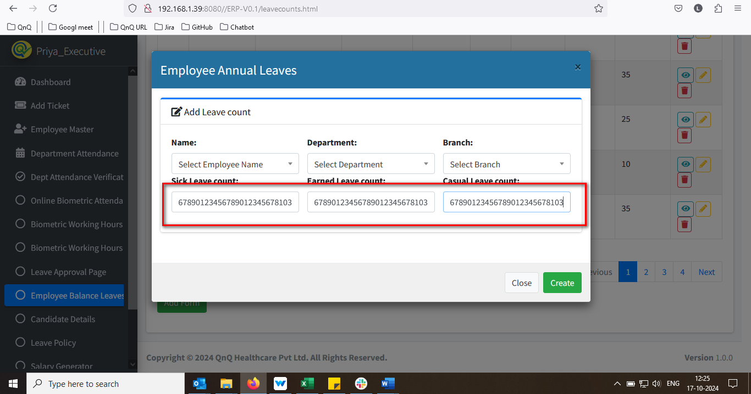//
12. The Days field allow letters and special symbols when pasting content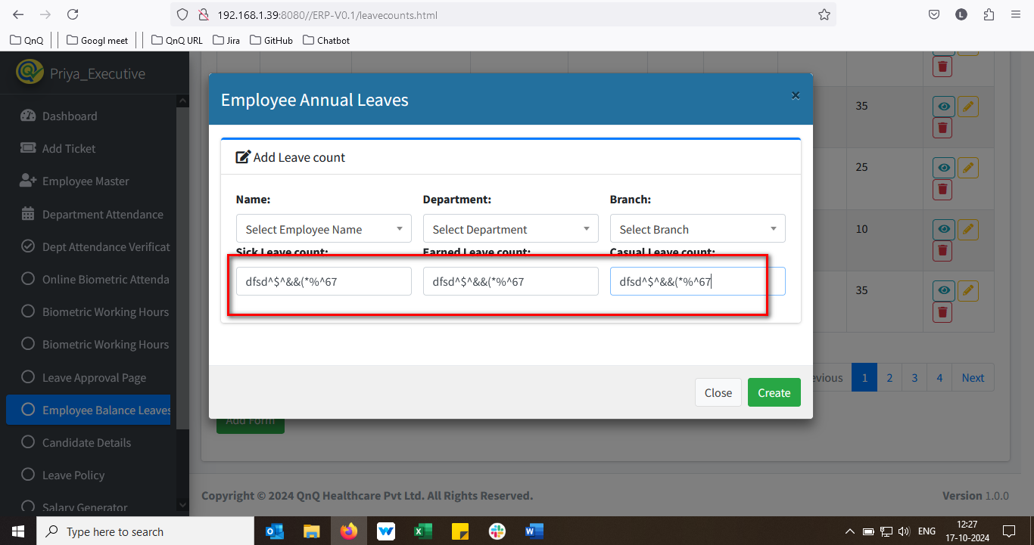 //
13. Unwanted Header column display in Add Leave Leaves pop up 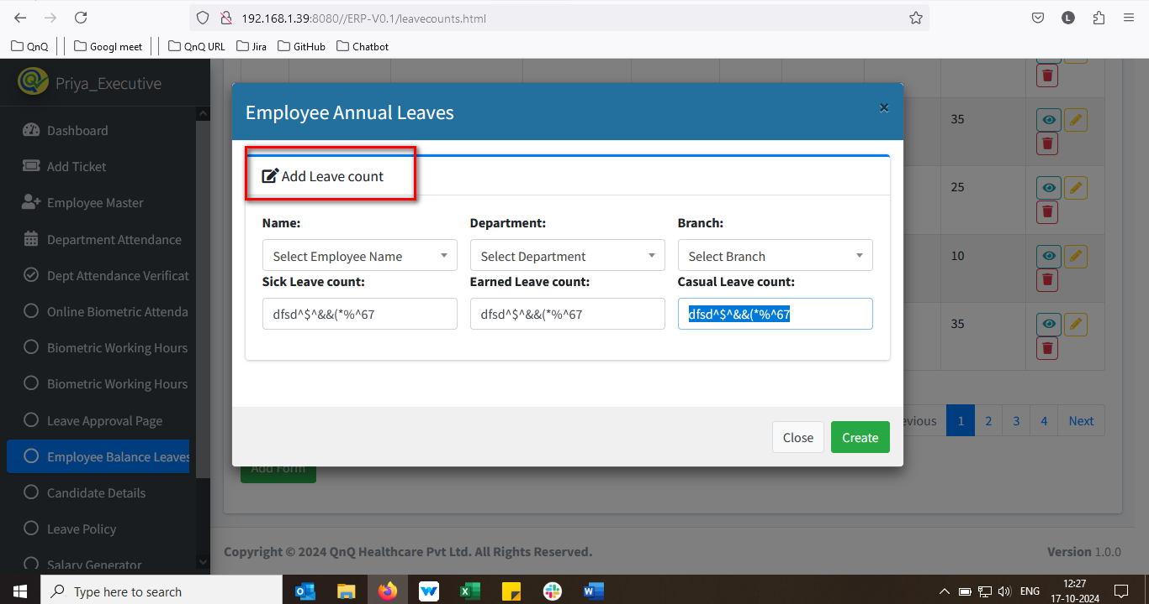 //
14. Mismatch column header in Add Leave pop up 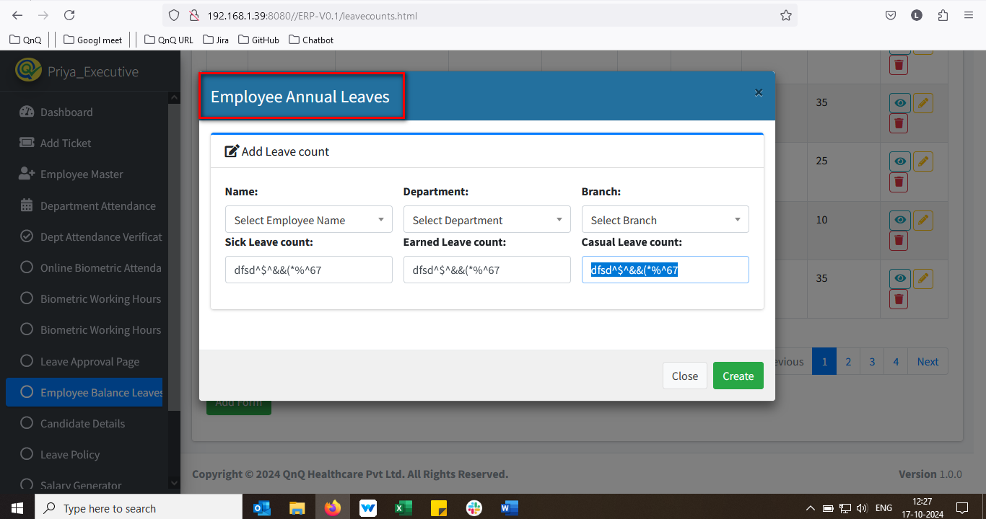 //
15. Pop up getting close without click close button 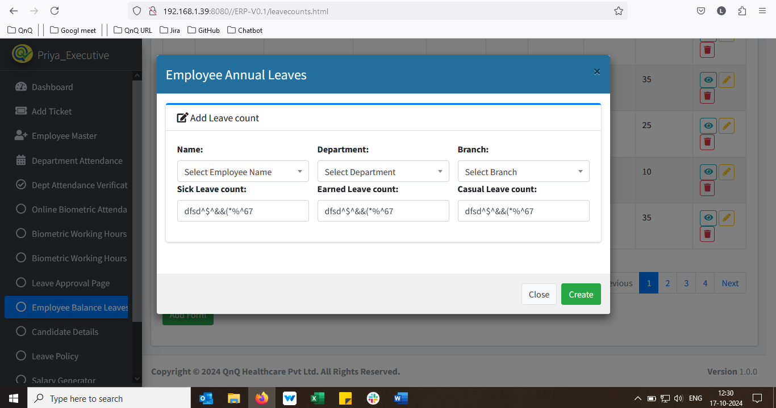 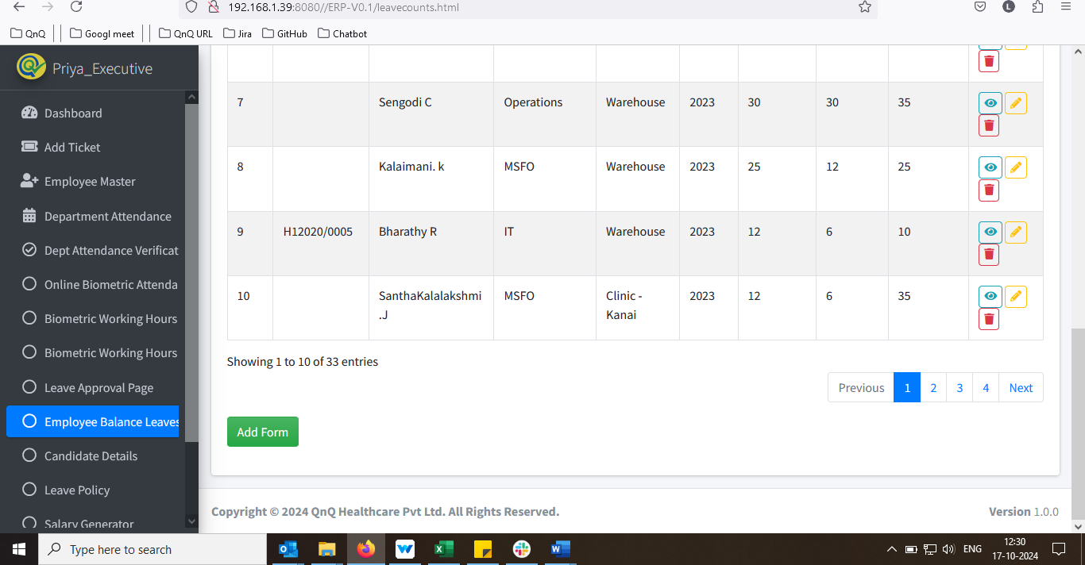 //
16. Confirmation message not display while click close button with the value 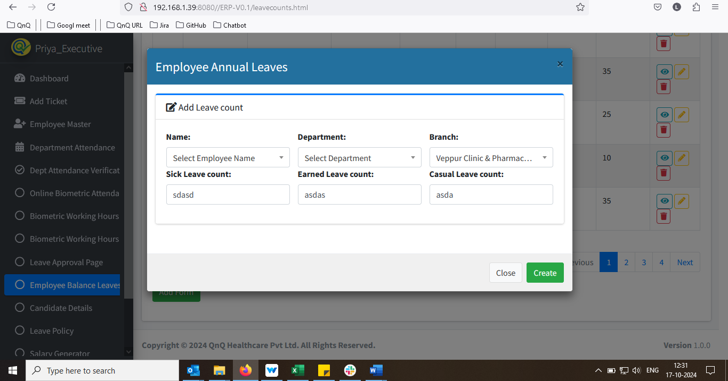 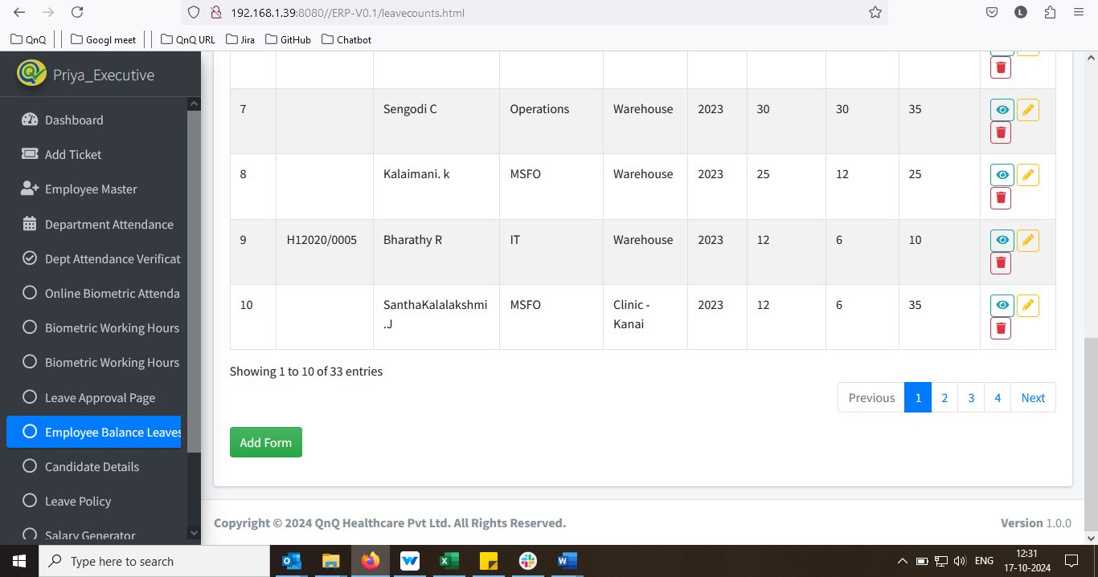 //
17. When the Add Leave button is pressed, existing values appear 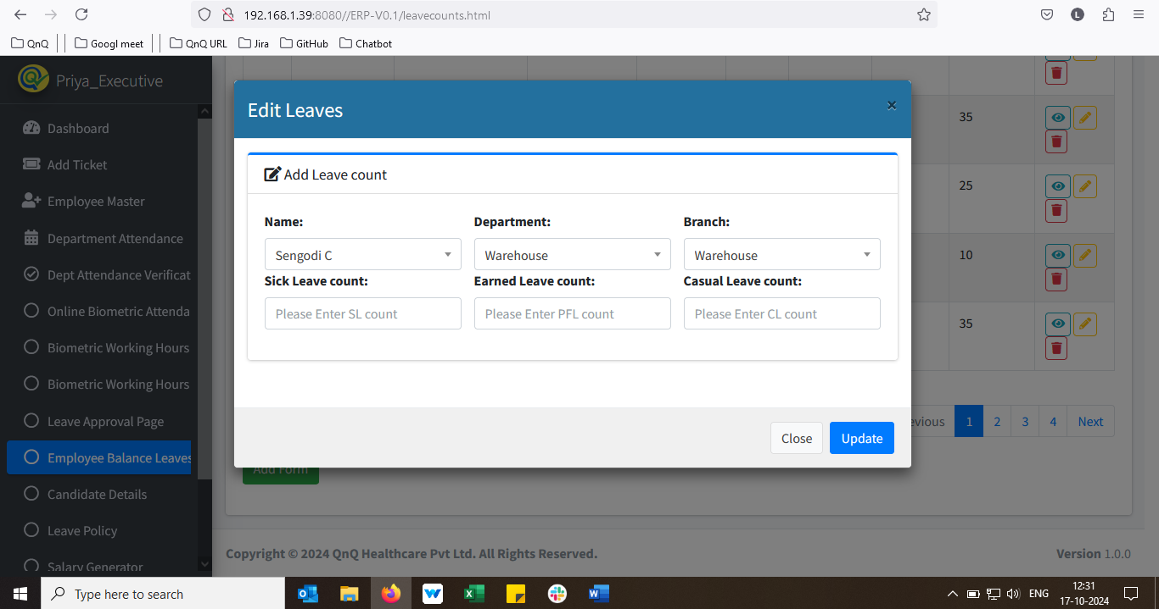 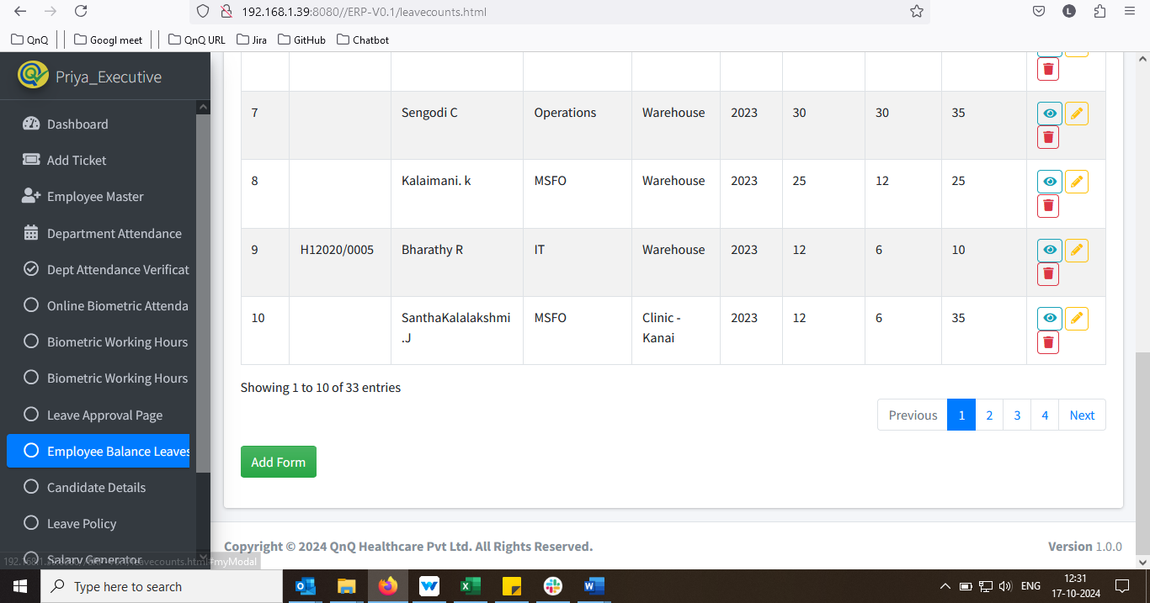 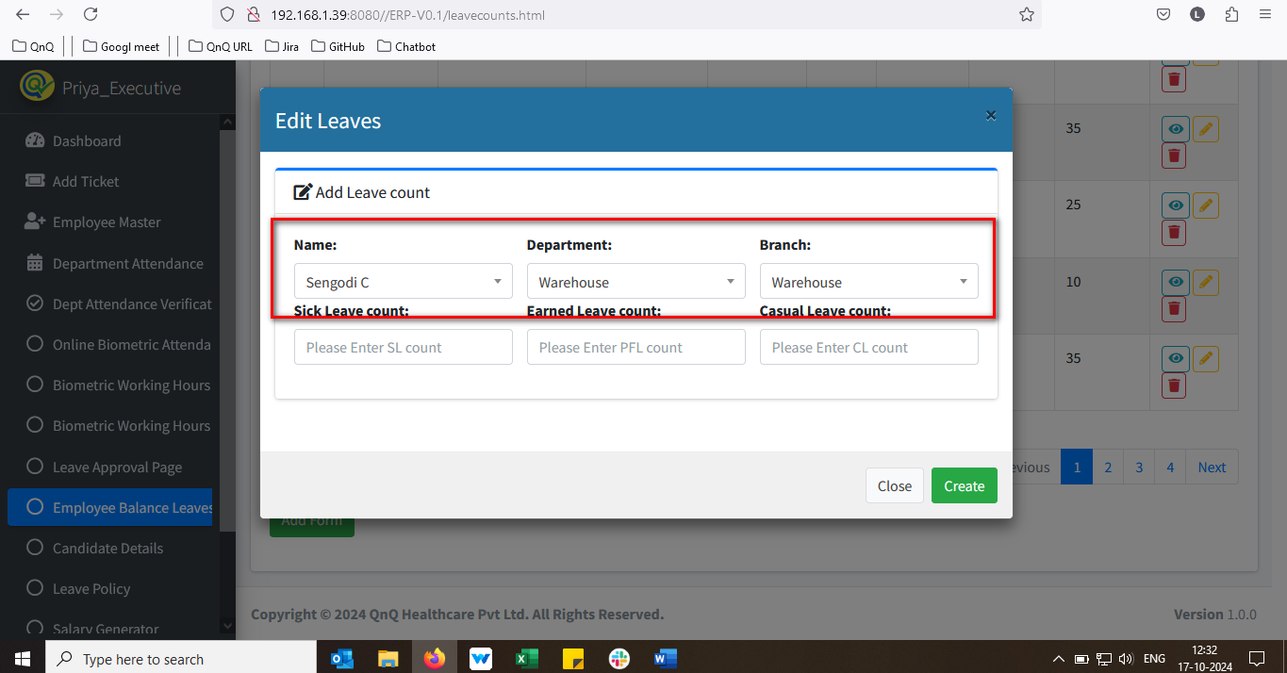 //
18. Success message not display while create the Leave count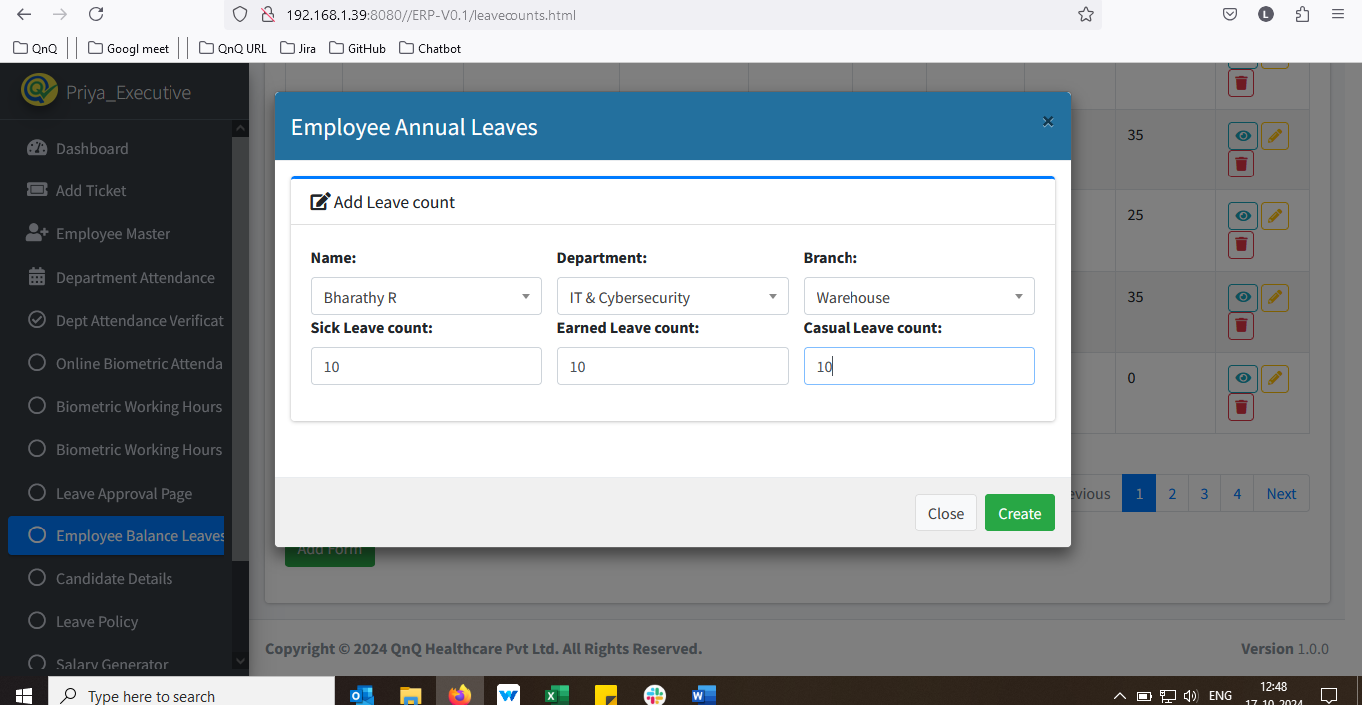 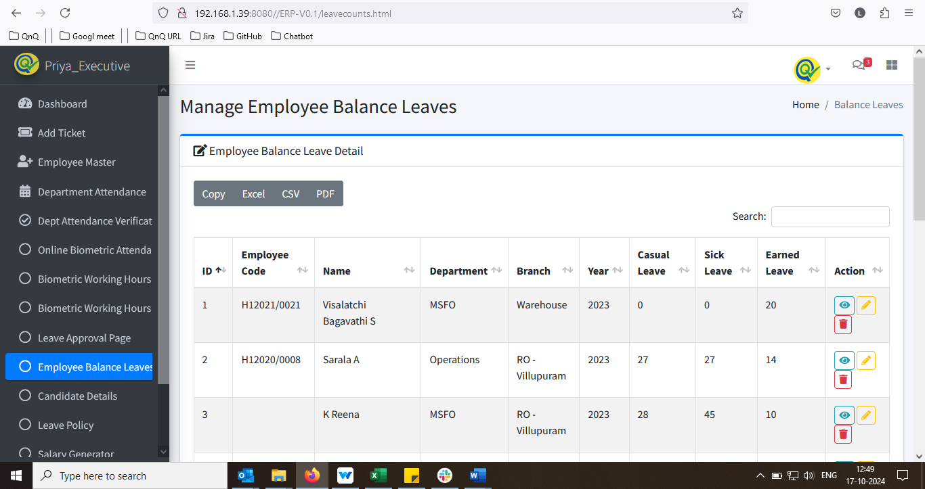 //
19. Mismatch content display in the Delete confirmation pop up 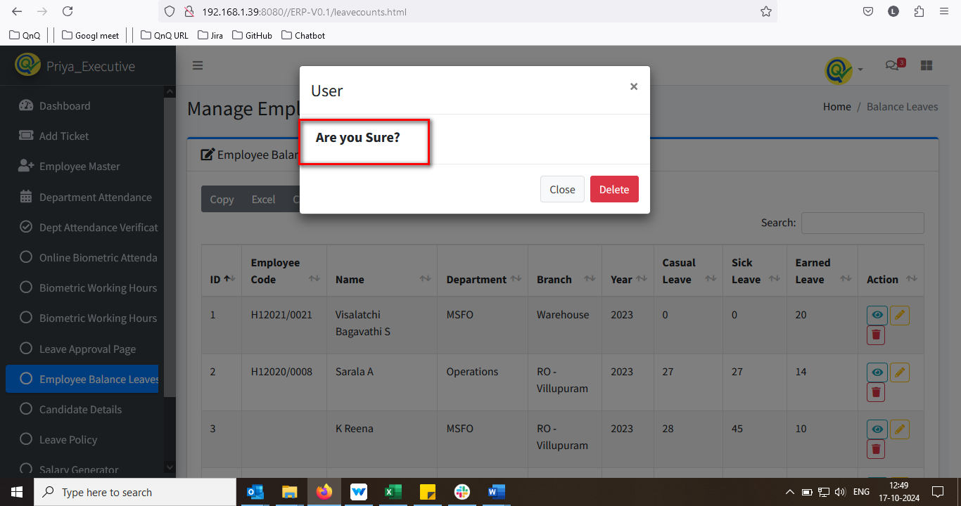 //
20. Mismatch header value display in Delete confirmation pop up 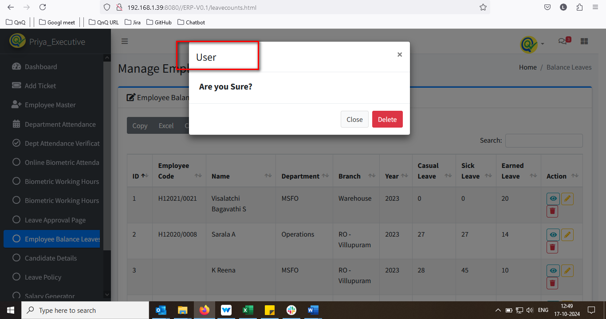 //
21. Leave count values not display in list grid and pop up 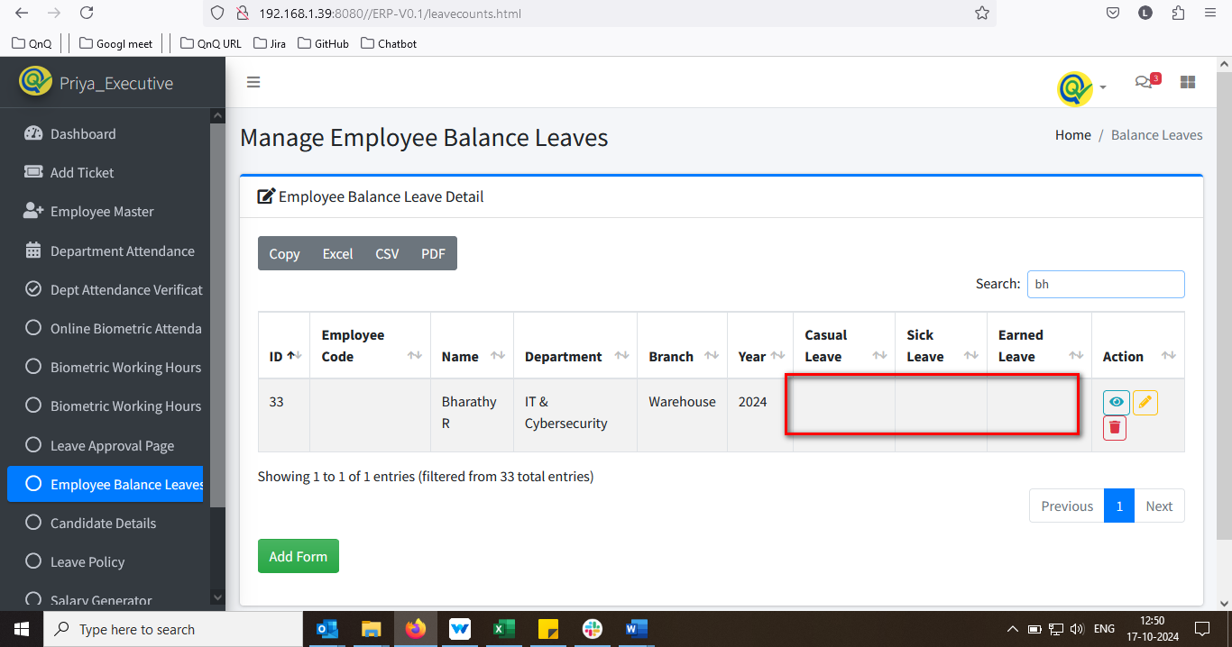 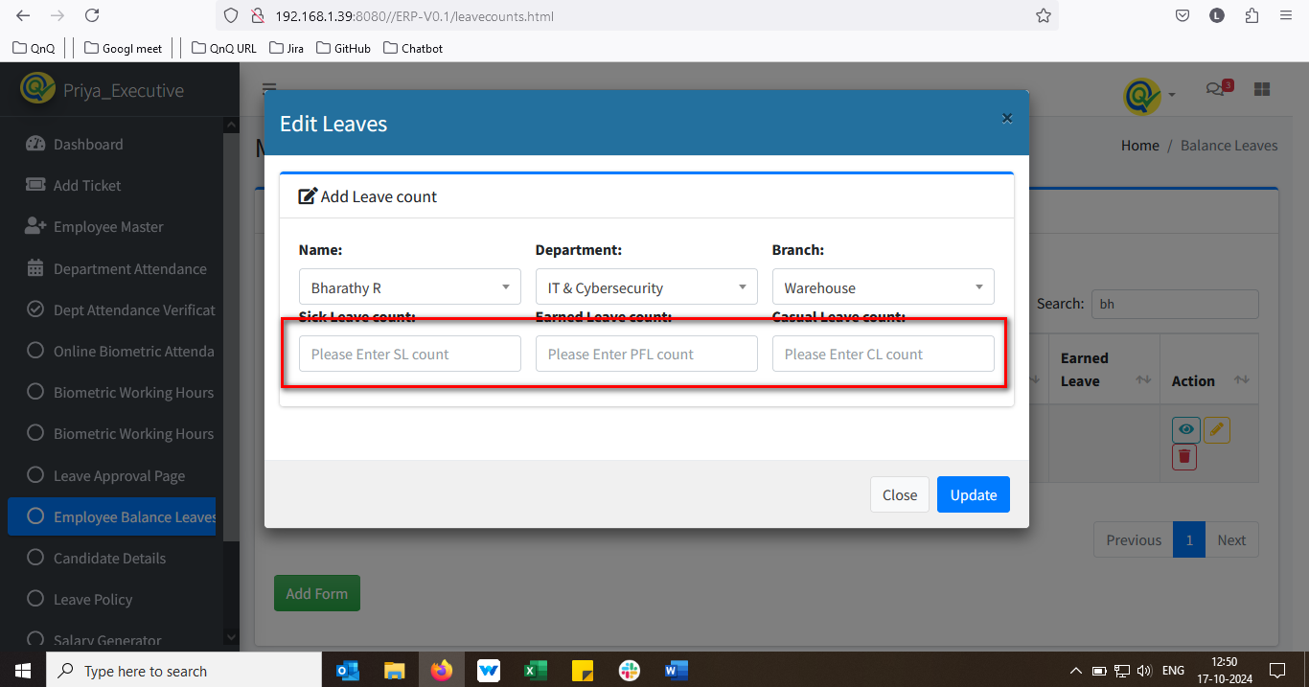 //
22. Name value not display while click the edit icon 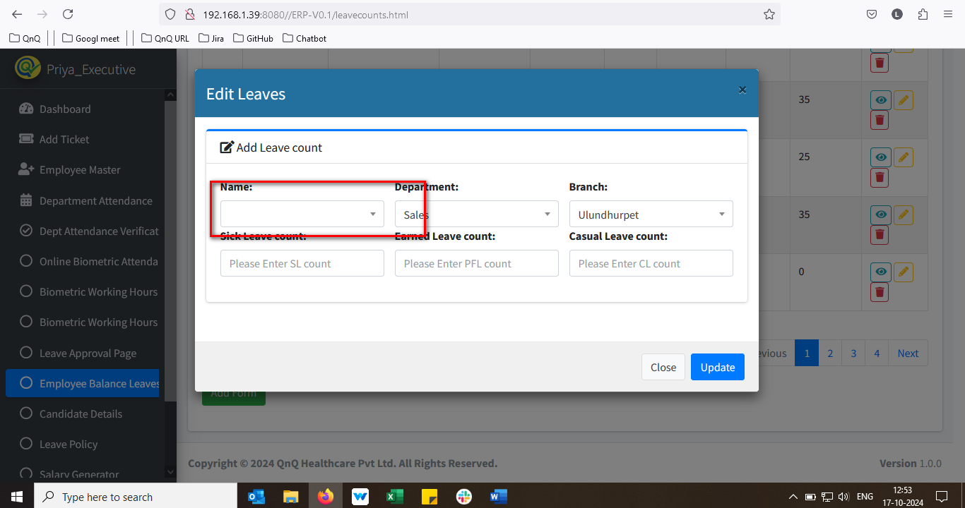 //
23. Unwanted error message display while click the update button without change any value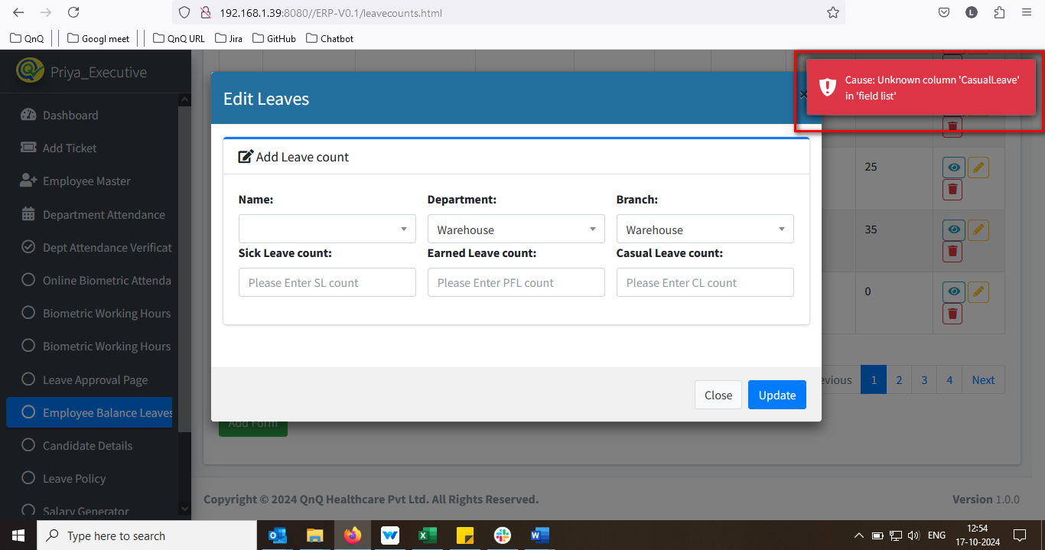 //
24. Mismatch delete success message display while delete the record 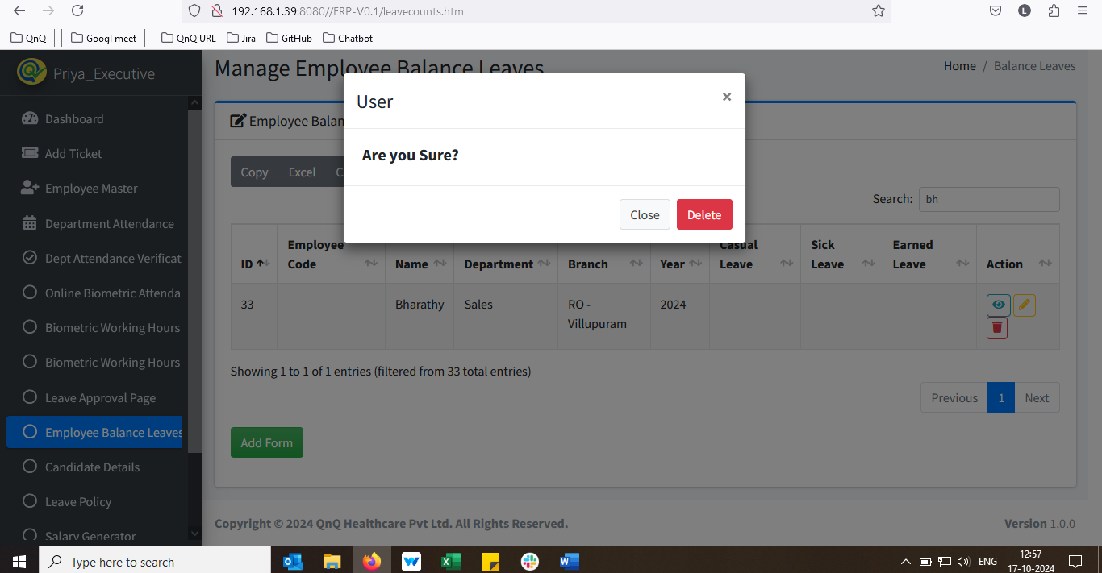 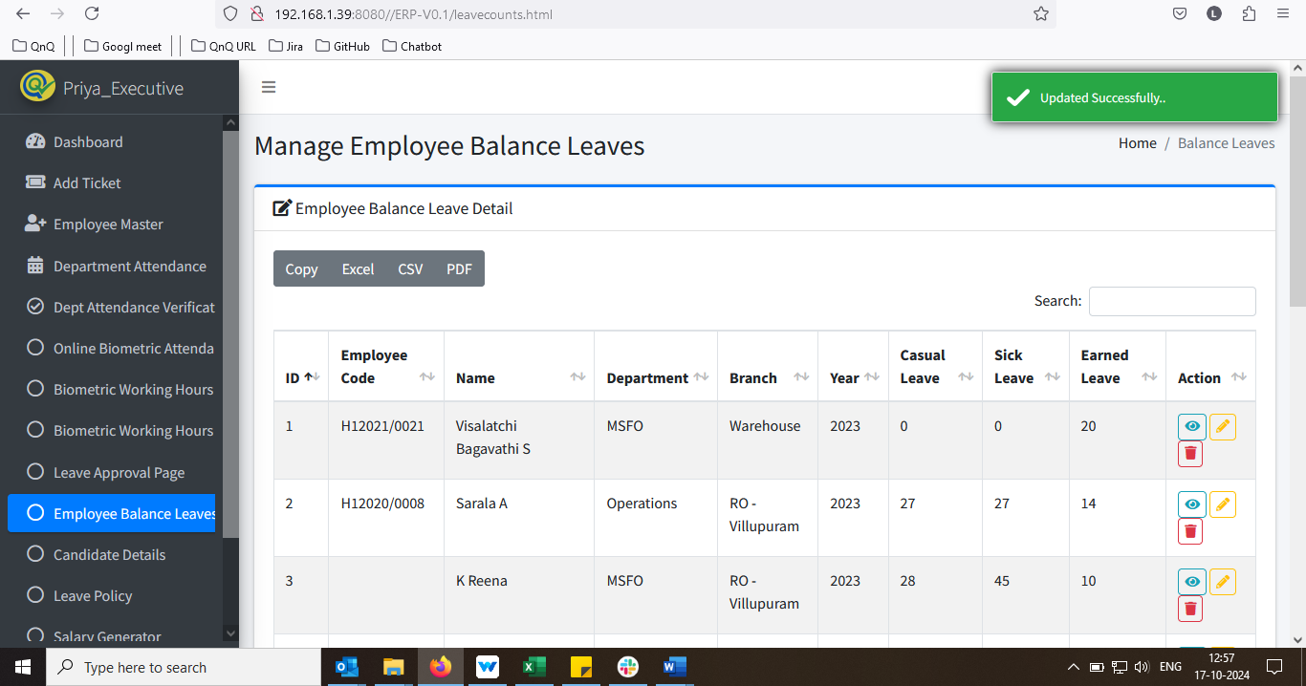 //
25. Leave count value not getting fetch in self-employee portal/page 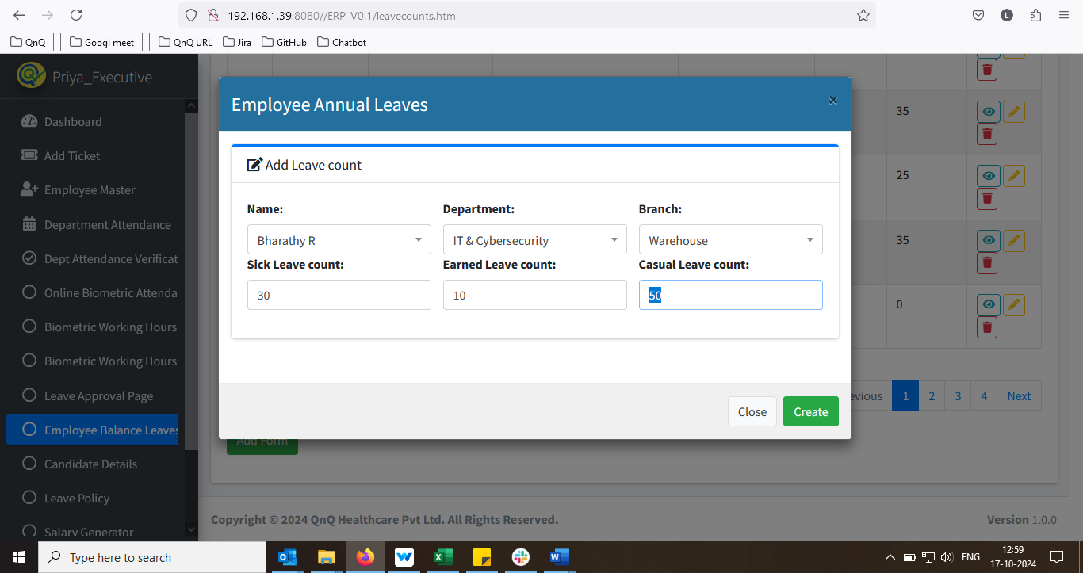 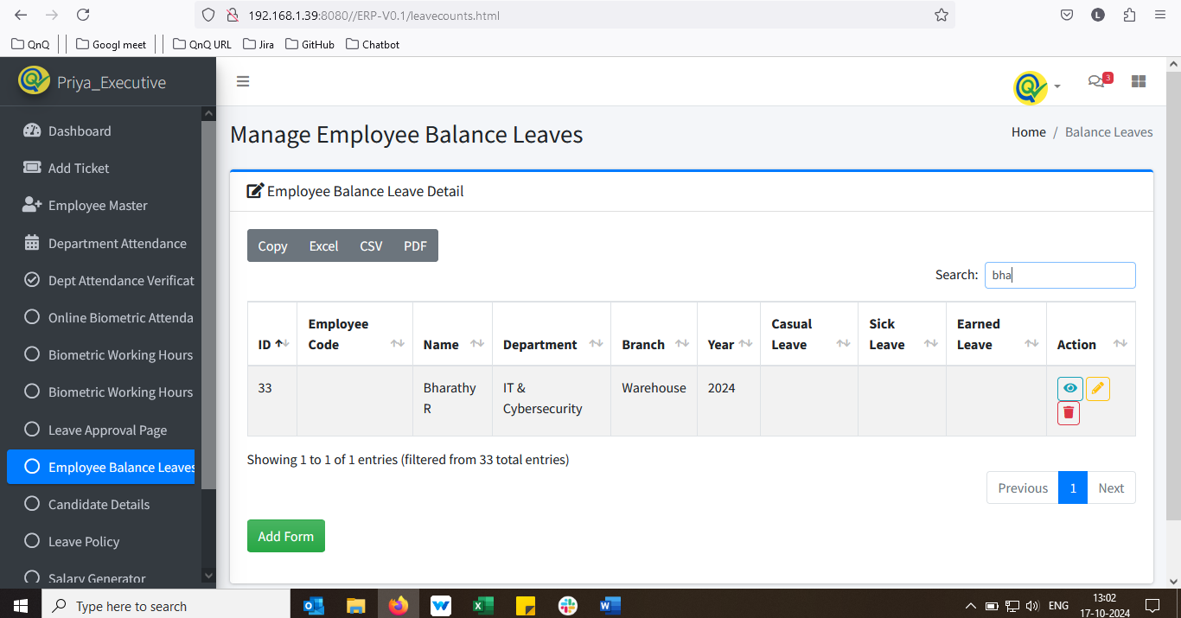 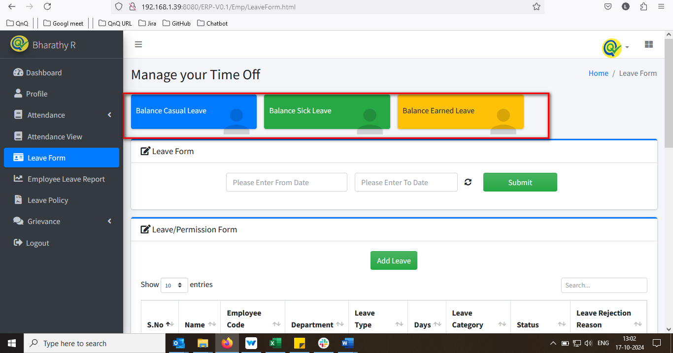 //
26. User can update the value in view mode 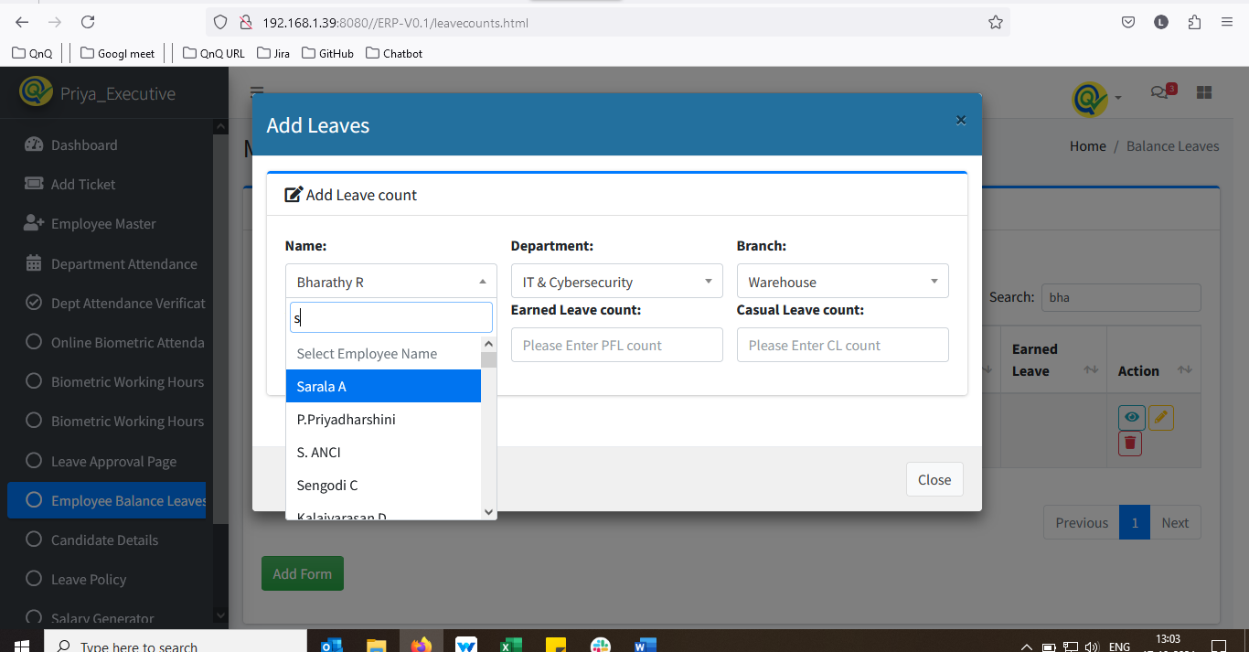 //
27. Mismatch inner text display for EL Count field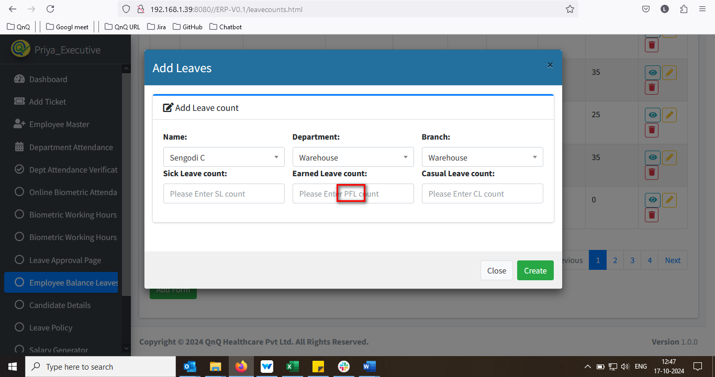 //
28. Unwanted Copy button display in list grid 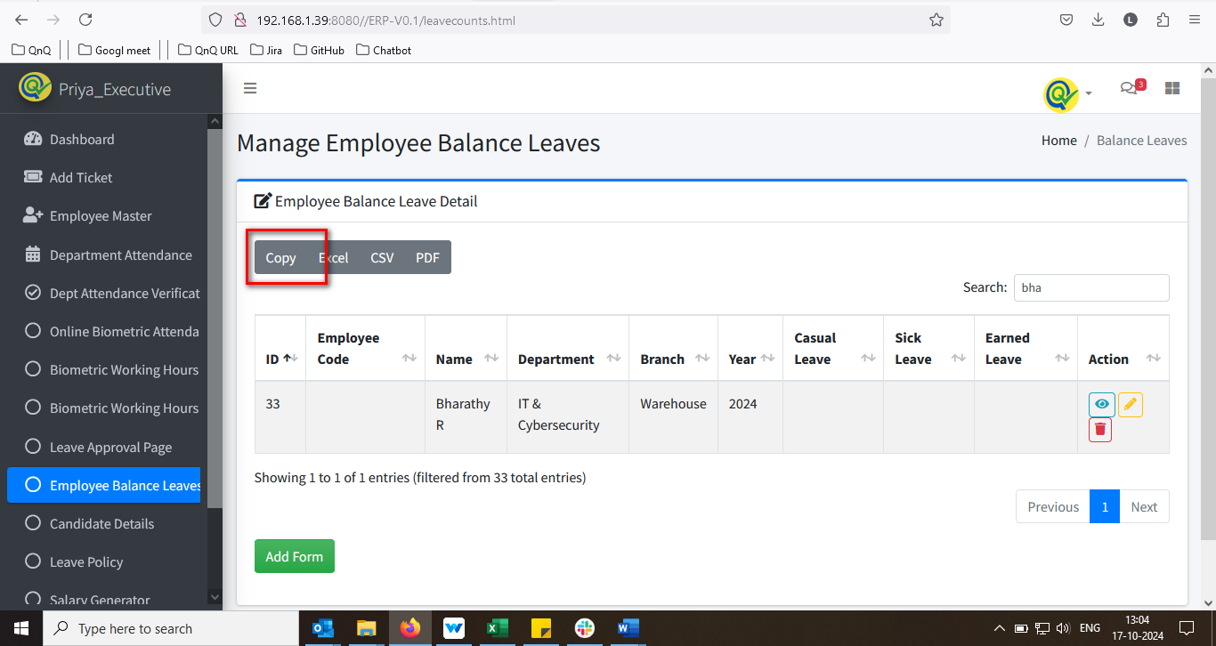 //
29. Sheet name not display in Excel 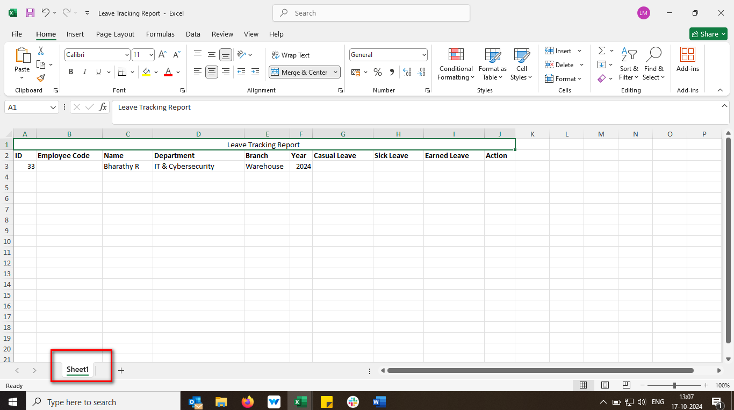 //
30. Null value display in download CSV file – Header column not display, Header column not display properly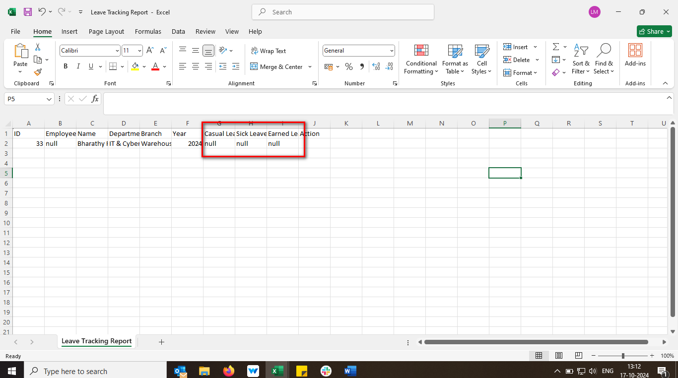 //
31. Mismatch File name display in the download file 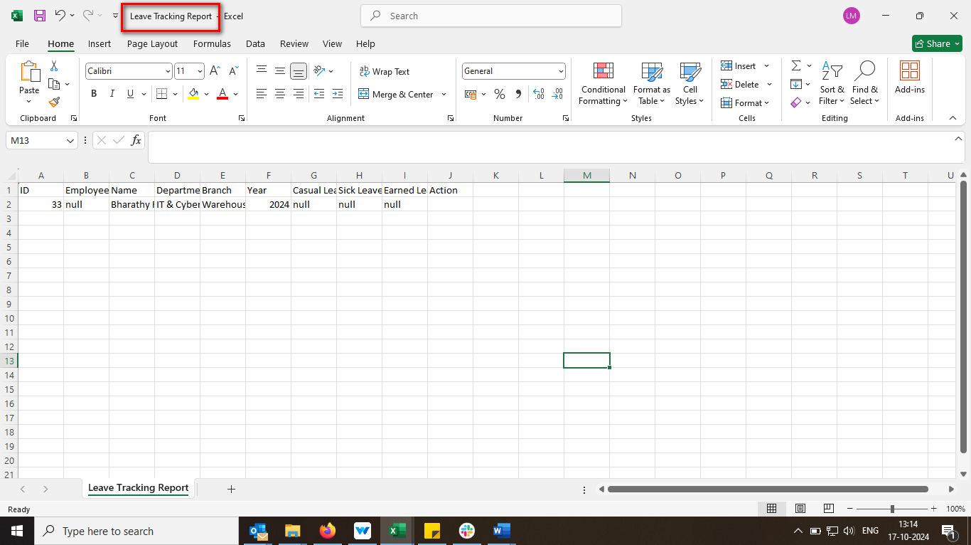 //
32. Unwanted column display in download file 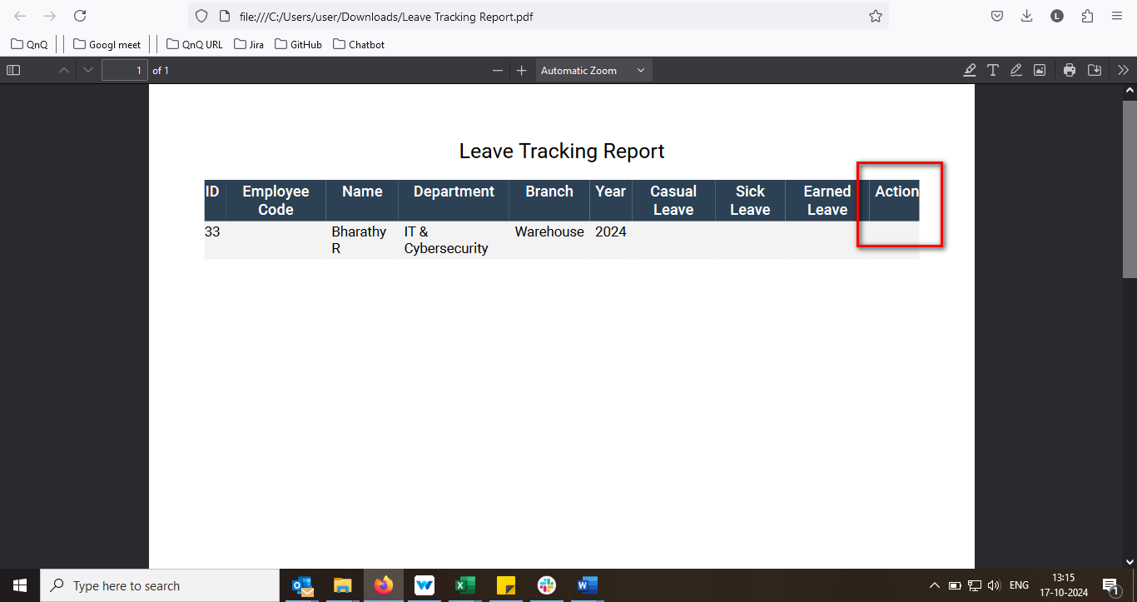 //
33. Unable to update the record 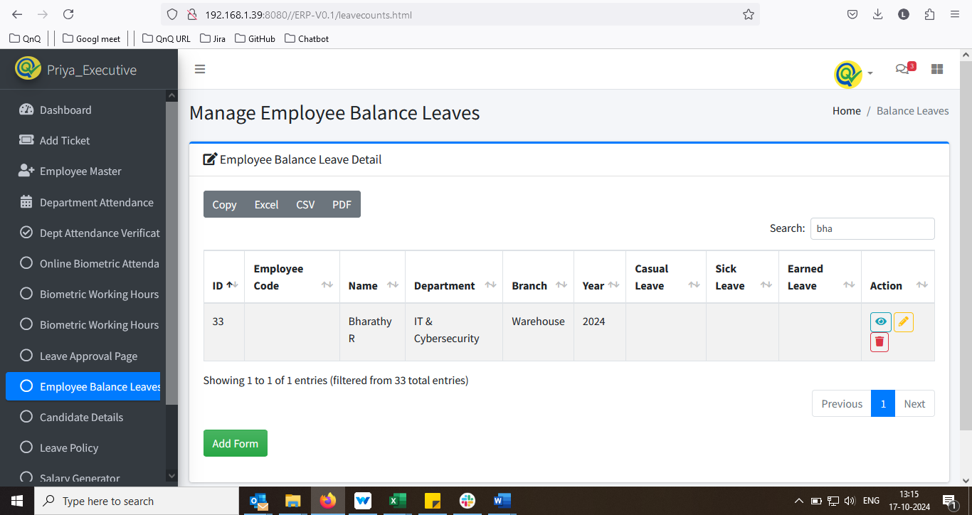 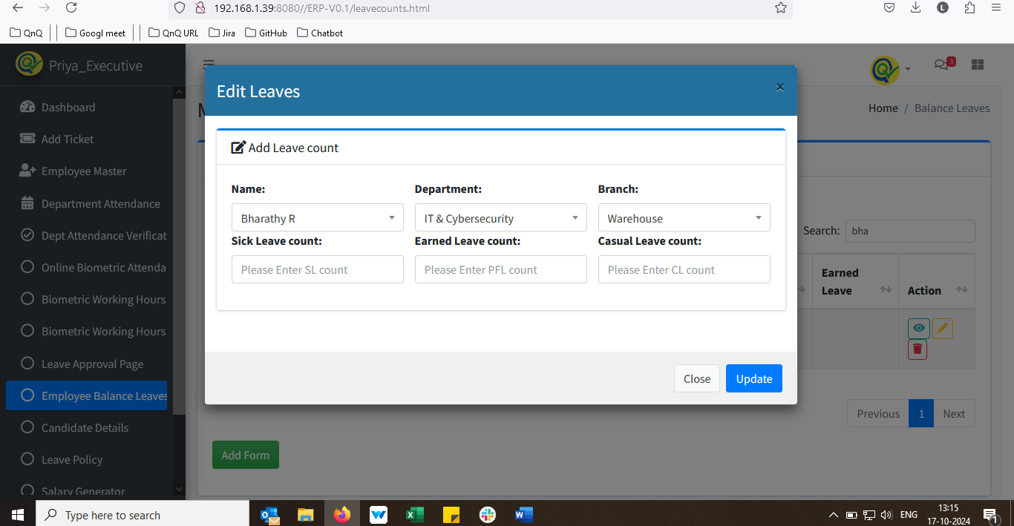 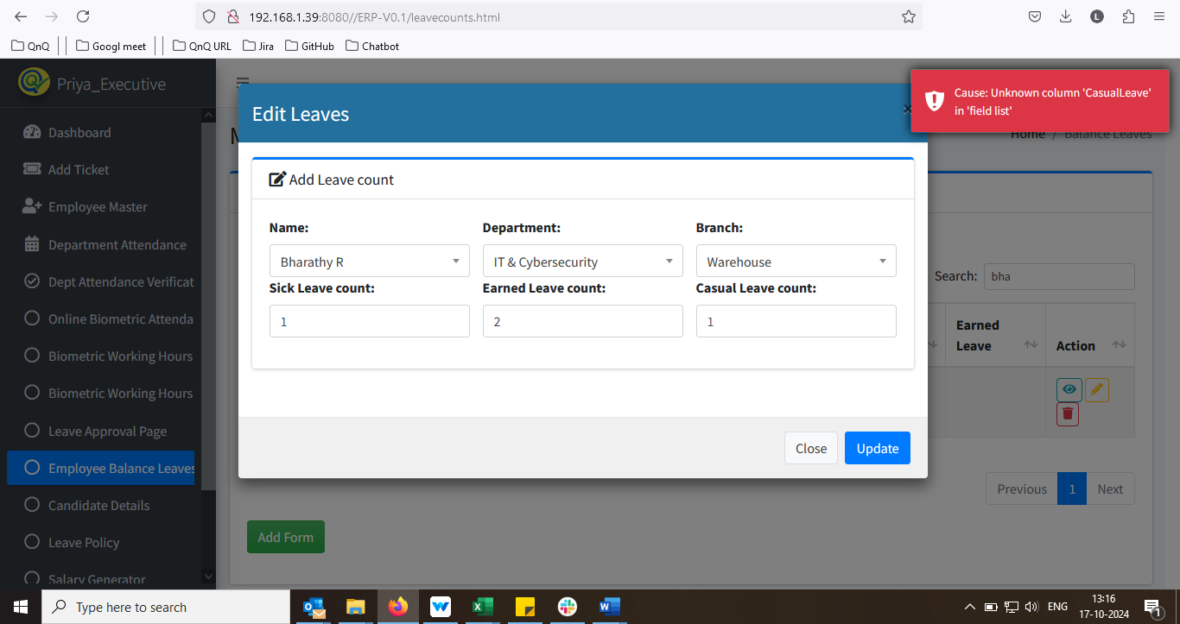 //
34. Unwanted Header column display in Add Leave Leaves pop up 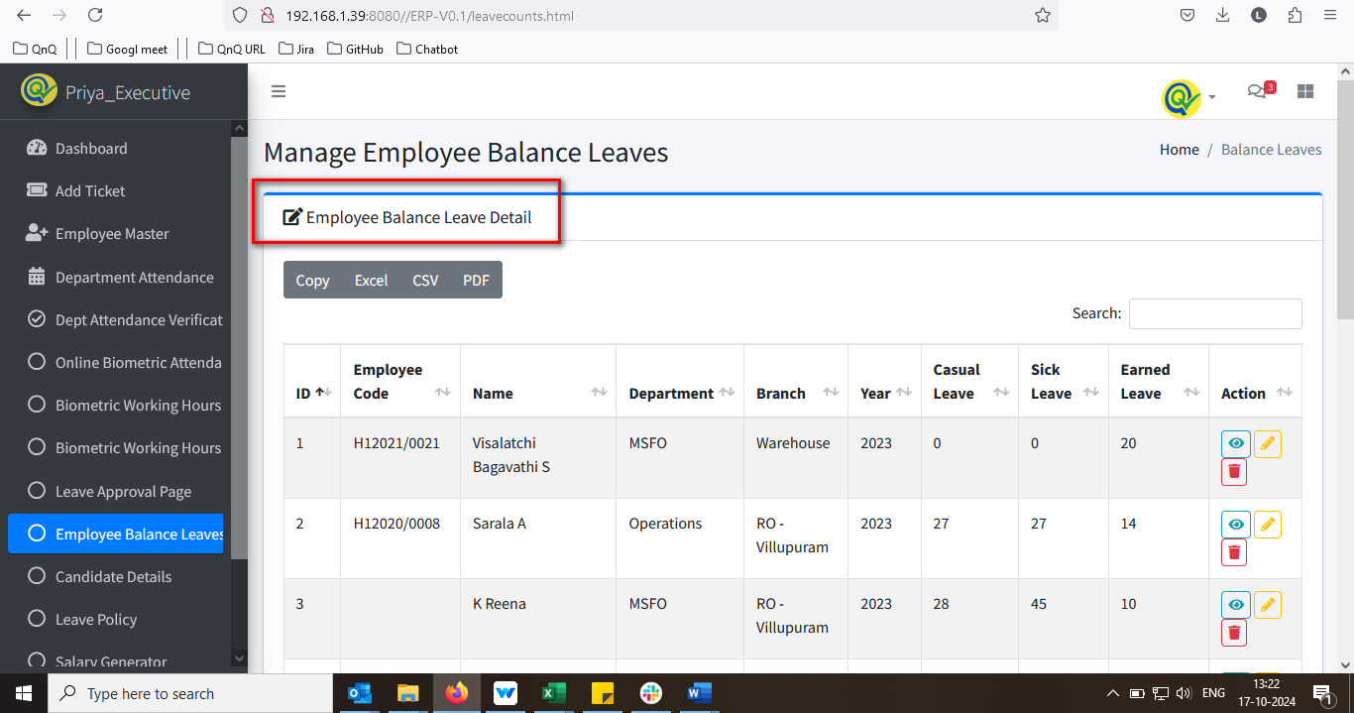 //
35. Inner Text value not display in Search box 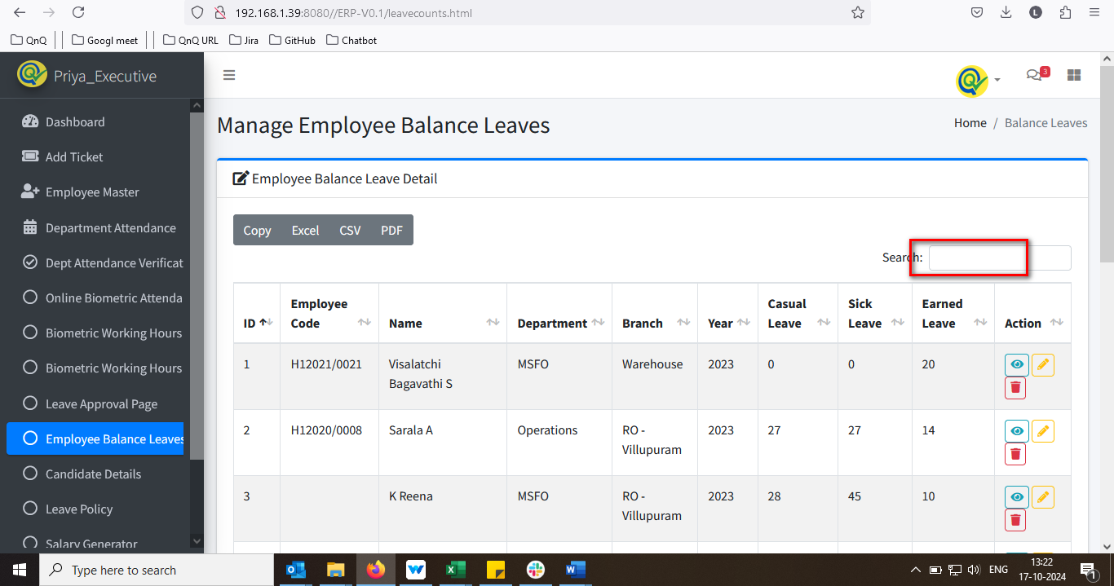 //
36. System allows to create the duplicate record 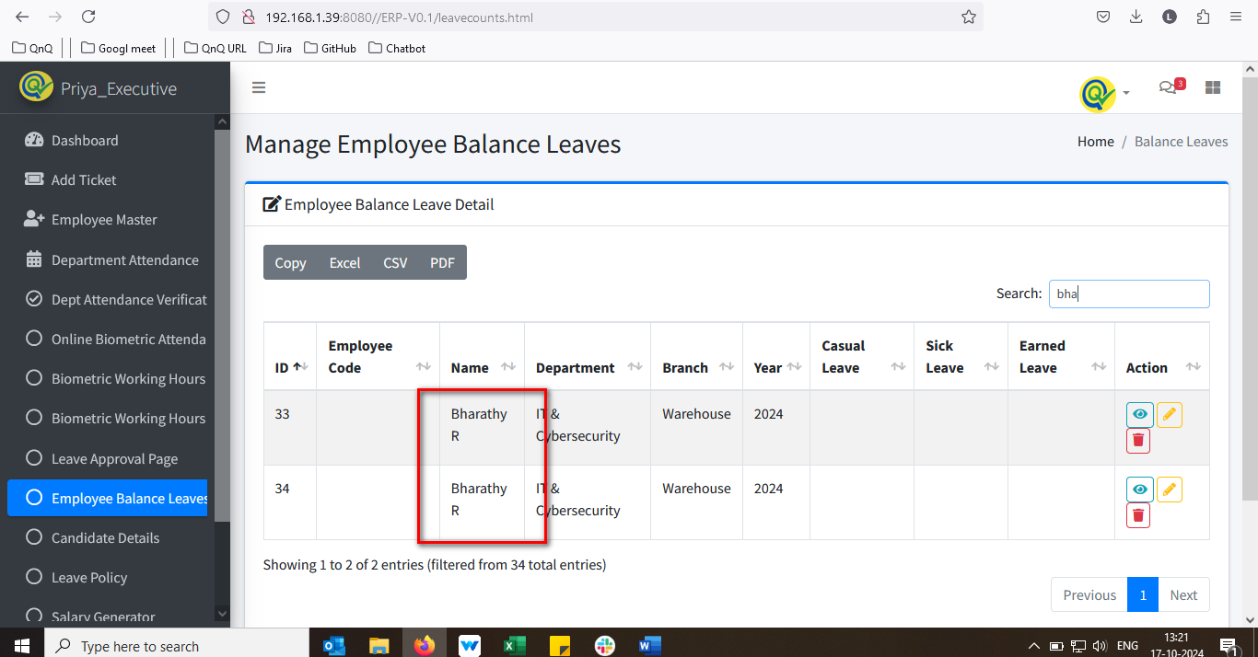 //
37. Mismatch Menu icon and name display  